

AI Driven Cyber Security & Ethical Hacking Career Track Program

Module: 01
Assignment No: 02
Assignment Title: Case study on Eternal Blue and Wanna cry attack

Date: 10-10-2026
Submitted By: Mainull Islam
Submitted To: Safwan Muntasir Sir

Table of content

- What is WannaCry?
- What is EternalBlue?
- How did WannaCry spread to computers around the world?
- Which countries or organizations were significantly affected?
- What were the major consequences of the attack?
- How did the attack affect businesses and public services?
- What actions were taken to stop or reduce the spread of the attack?
- What lessons can individuals and organizations learn from this incident?
- Why is it important to keep computer systems updated?
- Mention the lesson learned from this incident.
- Photos and screenshot
- References

Task: 1

What is WannaCry?
- Ans: WannaCry is a type of malicious software known as ransomware. It is usually designed to block access to a computer or encrypt its files and then demand money to restore access. The WannaCry attack began on 12 May 2017. WannaCry was especially dangerous because it could spread automatically to other vulnerable Windows computers connected to a network.

What is EternalBlue?
- Ans: EternalBlue is a cyber exploit that takes advantage of a security vulnerability in Microsoft's Windows Server Message Block (SMB) protocol. In April 2017 EternalBlue became widely known because WannaCry used it to infect vulnerable computers and spread across networks. So EternalBlue is an exploit that helps malware to gain access to vulnerable systems and spread over.

How did WannaCry spread to computers around the world?
- Ans: WannaCry spread quickly because it combined ransomware with worm-like behaviour. The malware searched for computers running vulnerable versions of Windows, particularly systems that had not installed the necessary security patches. WannaCry used the EternalBlue exploit to target a weakness in the SMB protocol on vulnerable computers. Once a system was successfully infected, the ransomware could begin encrypting files and displaying a ransom demand. The malware searched for other vulnerable systems that it could reach through network connections. This is how it spread quickly.

Which countries or organizations were significantly affected?
- Ans: WannaCry affected computers in more than 150 countries. The UK's National health service faces a great disruption. Spain’s Telecommunications company Telefónica was among the organizations reported to have been affected. Russia,India and other country organizations experienced the issues.

What were the major consequences of the attack?
- Ans: The WannaCry attack had several serious consequences. Many victims could no longer access important documents and files because the ransomware had encrypted them. Hospitals and other institutions experienced difficulties using computer systems needed for their daily operations. Organizations faced costs associated with system recovery, technical support, lost working hours, and service interruptions.

How did the attack affect businesses and public services?
- Ans: Businesses affected by WannaCry experienced interrupted operations, unavailable files, and delays in completing normal work. Some organizations had to disconnect computers from their networks to reduce the risk of further infection. The resulting downtime could affect customers, production, communication, and business income.
- Healthcare services were particularly affected in the United Kingdom. Some NHS organizations could not use their computer systems normally, and appointments had to be cancelled. In several areas, patients had to travel farther to reach emergency departments.

What actions were taken to stop or reduce the spread of the attack?
- Ans: Several measures were taken to stop the spread of the attack.
- Organizations were advised to apply Microsoft's MS17-010 security update to vulnerable Windows systems. Microsoft also provided patches for certain older Windows versions.
- Disconnecting affected computers from networks helped to stop spreading from computer to computer. A security researcher discovered a kill switch of that malware which slowed down the outbreak of this malware.

What lessons can individuals and organizations learn from this incident?
- Ans: The WannaCry incident provides several useful lessons. For individuals, keep the operating system and applications updated. Use reputable antivirus or endpoint security software. Use strong, unique passwords and enable multifactor authentication when available.
- For organization, Establish a regular process for installing and checking security updates. Replace unsupported operating systems and outdated software. Separate important systems into protected network segments. Create and regularly test an incident-response and business-continuity plan.

Why is it important to keep computer systems updated?

Mention the lesson learned from this incident.
- Ans: Keeping computer systems updated is important because software developers regularly release security patches to fix known vulnerabilities. If users do not install these patches, attackers may take advantage of weaknesses that are already understood.

Task: 2

Photos and screenshot

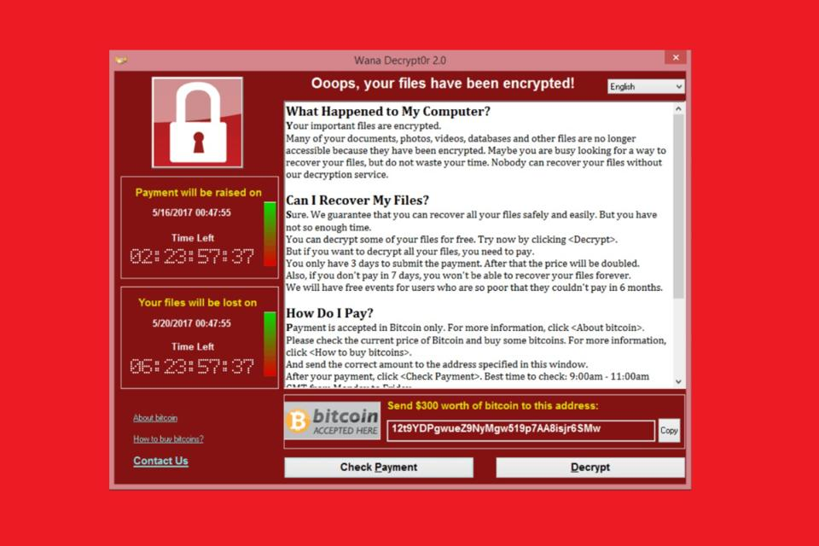
- Wanna cry ransom screen

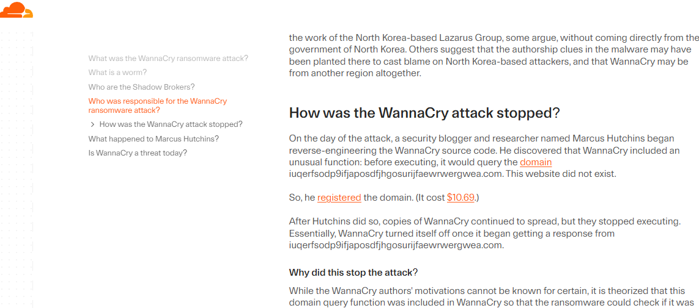
Cloudflare report screenshot

Task: 3

Referrences

https://www.cloudflare.com/learning/security/ransomware/wannacry-ransomware/

https://www.microsoft.com/en-us/security/blog/2017/05/12/wannacrypt-ransomware-worm-targets-out-of-date-systems/

https://digital.nhs.uk/cyber-alerts/2017/cc-1411

